*Case Study on BA*

A University Registration System :--

1.Professors indicate which courses they will teach on

2.A course catalog can be printed

3.Allow students to select on line four courses for upcoming semester.

4.When the registration is completed, the system sends

information to the billing system.

5.Professors can obtain course rosters on line.

6.Students can add or drop classes on line.

Use Case Diagram

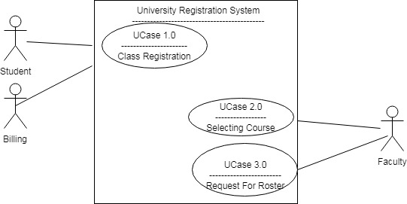

Use Case Documents

|  |  |  |  |  |
| --- | --- | --- | --- | --- |
| Use Case Id | Created By | Created At | Actor | Description |
| UCase 1.0 | Somnath Biswas | dd/mm/yyyy | Student,Billing | Student and Billing Entity |
| UCase 2.0 | Somnath Biswas | dd/mm/yyyy | Faculty | Faculty Entity |
| UCase 3.0 | Somnath Biswas | dd/mm/yyyy | Faculty | Faculty Entity |

Scenario Points

UCase 1.0

1.if student attended educational eligibility check for financial

Eligibility after clearing that point ,student will be eligible for enrollment.

2.Billing subsystem checks for account entry if amount entered appropriate then process will be further go to registration sub-process with positive signal from account sub-process.

UCase 2.0 & UCase 3.0

3.Each Faculty can request to get updated list of course and rosters provided they are ready.

Activity Diagram

1>Student Entity

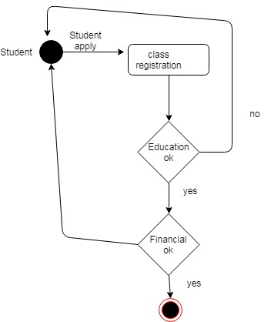

2>Billing Entity

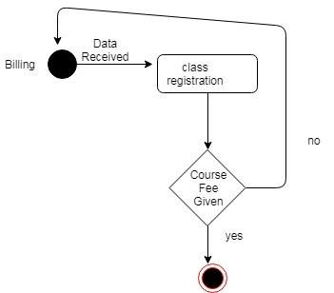

2>UCase 2.0

Faculty Entity

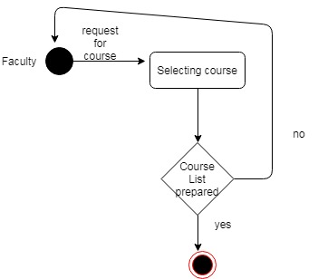

3>UCase 3.0

Faculty Entity

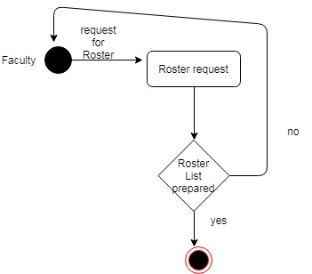

Resources for flow chart:--

https://online.visual-paradigm.com/tutorials/flowchart-tutorial/